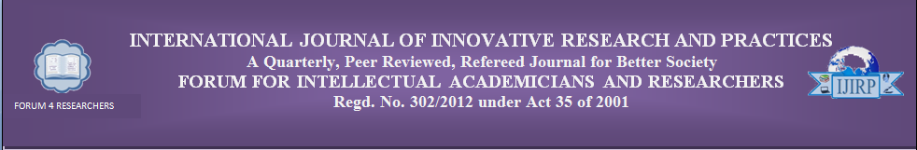
Copyright Transfer and Declaration for the IJIRP
To
Date:
N. Santosh Ranganath
Associate Editor
International Journal of Innovative Research & Practices
Forum for Intellectual Academicians and Researchers
M.I.G.-182, Opp: Z.P., A.P.H.B. Colony
Srikakulam – 532001, Andhra Pradesh, India
Ph: 9440069570
e-mail: editor@forum4researchers.com

Sub: Assignment of Copyright

I/We, --------------------------------------------- and ------------------------------------------------------- the copyright owner/s of the Article “----------------------------------------------------------------------------------------------------------------------------------------------”, do hereby authorize you to publish the above said article in the “International Journal of Innovative Research & Practices”.

I/We further state that:
- The Article is our original contribution. It does not infringe on the rights of others and does not contain any libelous or unlawful statements.
- Wherever required I/we have taken permission and acknowledged the source.
- The work has been submitted only to this “International Journal of Innovative Research & Practices” and that it has not been previously published or submitted elsewhere for publication.
I/We hereby authorize you to edit, alter, modify and make changes in the Article to make it suitable for publication.

I/We hereby assign all the copyrights relating to the said Article to the “International Journal of Innovative Research & Practices”.
I/We have not assigned any kind of rights of the above said Article to any other person/Publications.

I/We agree to indemnify the “International Journal of Innovative Research & Practices” against any claim or action alleging facts, which, if true, constitute a breach of any of the foregoing warranties.

1. Author Name: 2. Co-author Name:

Signature: Signature:

